Studio Q Program | Semester 2, 2021
Information Kit
About Studio Q
Welcome! At Studio Q we offer a range of face-to-face theatre and performance training programs for different age groups, skill levels and abilities. All of these delivered by Q Theatre at the Joan Sutherland Performing Arts Centre, Penrith.
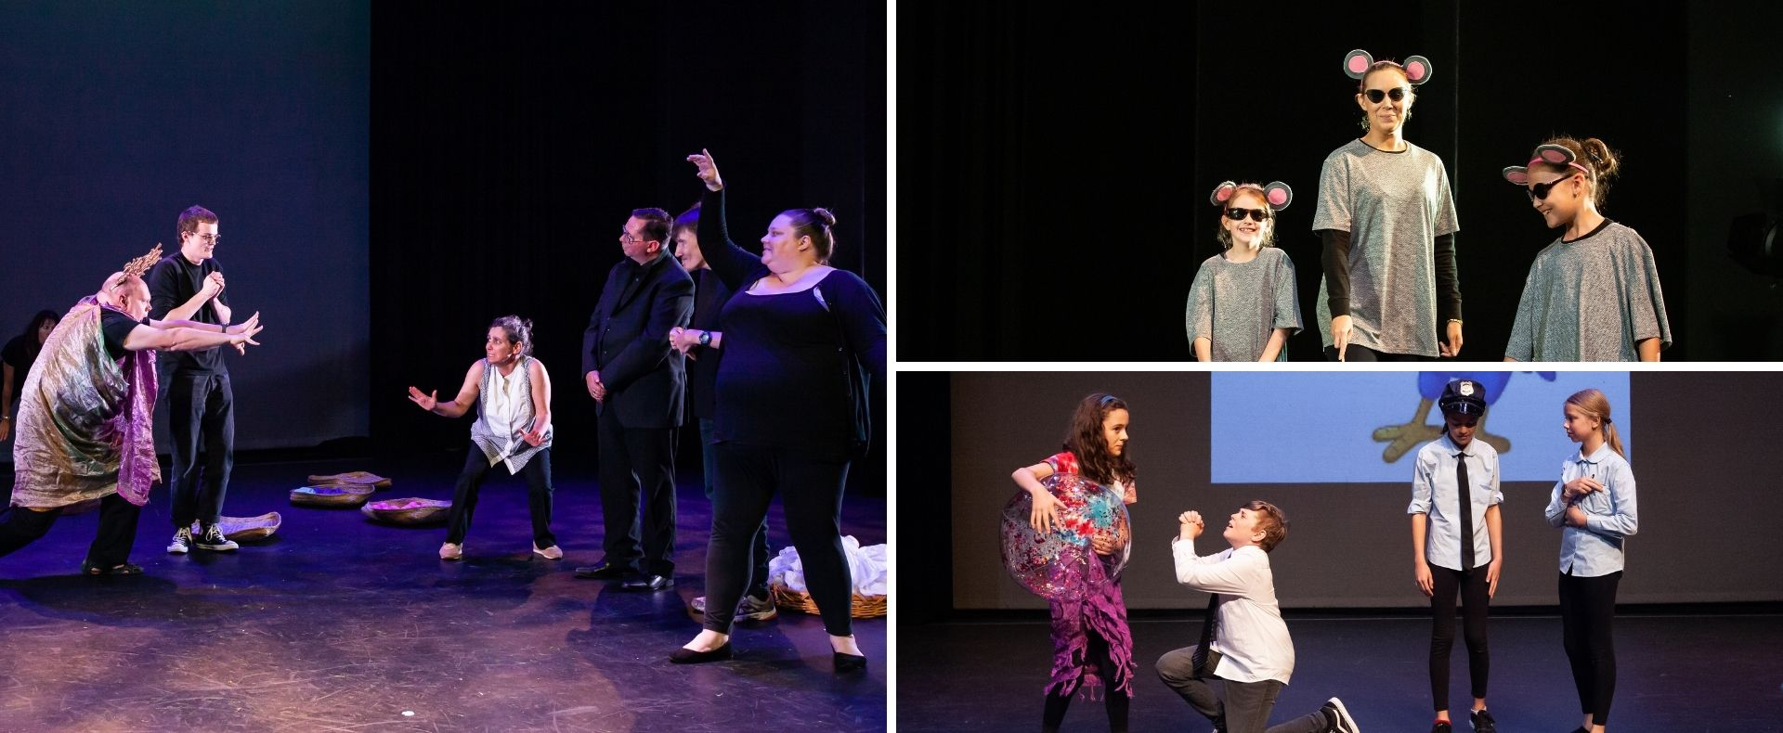
General Course Outline and Structure
Run across an 8-week term, aligned with NSW’s public school terms, participants attend a weekly workshop to learn and develop new skills, whilst working towards a performance outcome.
The following courses are being offered in Terms 3 – 4, 2021 (subject to meeting minimum participant requirements):
Access Artists Ensembles are courses for artists who identify as living with disability. These are:
Young Adults | Ages 18 – 26 | Fridays at 1:30pm
Adults | Ages 26+ | Fridays at 10:30am
Young Artists Ensembles are designed for children and teens aged 5 – 18. They include:
Starting Out | Ages 5 – 8 | Saturdays at  9:30am and 12:30pm
Stepping Up | Ages 9 – 12 | Saturdays at  9:30am and 12:30pm
Ignite | Ages 13 - 15 | Saturdays at  9:30am and 1:30pm
Accelerate | Ages 16 - 18 | Tuesdays at 4:30pm

What Do I Wear? How Do I Prepare? What Do I Bring to the Studio Q Course?
Participants are required to wear loose and comfortable clothing, suitable for preparing them for the rigours of theatre-making, to all classes.
Acceptable Clothing: | Unacceptable Clothing:
Black/dark shirts | Short shorts
Black/dark pants or shorts | Miniskirts/dresses
Closed toed shoes | Open toed shoes/thongs/sandals
We strongly recommend all staff and visitors (12 years and older) wear masks inside The Joan. Please refer to the website for the latest NSW Government Health Orders:
www.thejoan.com.au/covid-safety
We recommend participants bring a bottle of water to each rehearsal to remain hydrated.
Accepted: | Not Accepted:
Bottle of water | Sugary drinks/fruit juices/soft drinks
Please Note: Food is not allowed unless through written agreement with Studio Q Management.
Course Fees
The 2021 fees are outlined below:
Course | Class Duration | Fees (Per Term) | Fees (Semester)
Starting Out and Stepping Up | 2 hours | $204 | $320
Ignite and Accelerate | 3 hours | $304 | $520
Access Ensembles | 2 hours | $184 | $320

Booking Process and Box Office Hours
How to Book
- Read the Terms and Conditions. Returning students, please note these are updated each term.
- Enrol and pay for your course through The Joan’s Box Office. We accept credit cards and EFTPOS.
  - By Phone: (02) 4723 7600
  - In Person: Visit The Joan – 597 High Street, Penrith
  - Online: Visit qtheatre.com.au/learning/
- Box Office will send you an enrolment form via email. Complete and submit your enrolment form as soon as possible.
- Check your email for confirmation of your enrolment

Box Office Hours
To ensure the safety of our patrons and staff, Box Office hours during COVID are as follows:
Phone | Monday – Friday | 9am – 4:30pm
Onsite | Monday & Tuesday | 2pm – 4.30pm
 | Wednesday - Friday | 9am – 4.30pm
Online | 24 hours, 7 days a week
These are subject to change. To check for updates, please visit our ‘Box Office’ page on The Joan’s website by clicking here.
Contact
For more information and enquiries, please contact our Theatre Programs Coordinator,
Ian Zammit.
Phone: Tuesday, 1pm – 8pm; Wednesday – Saturday, 9am – 4:30pm, on (02) 4723 7606
Email: creativelearning@penrith.city
Annual Studio Q Calendars
Plan for the year ahead! Print out the calendar for your class (please note the classes in the headings at the top of each), below and stick it on your fridge.
Access Ensemble Programs

Winter School Holidays: Saturday 26 June – Sunday 11 July, 2021
Term 3, 2021
 | Week 1 | Week 2 | Week 3 | Week 4 | Week 5 | Week 6 | Week 7 | Week 8
Friday | 16 Jul | 23 Jul | 30 Jul | 6 Aug | 13 Aug | 20 Aug | 27 Aug | 03 Sep
Spring School Holidays: Saturday 18 September – Monday 4 October, 2021
Term 4, 2021
 | Week 1 | Week 2 | Week 3 | Week 4 | Week 5 | Week 6 | Week 7 | Week 8
Friday | 15 Oct | 22 Oct | 29 Oct | 5 Nov | 12 Nov | 19 Nov* | 26 Nov* | 3 Dec**
* Technical Rehearsals for the Studio Q Showcase will be held in Week 6, Term 4 on 19 November; and Showcase in Week 7 on 27 November. Times announced closer to the dates.
** The final week of Term 4 will be a wrap class including ensemble reflection and graduation.

Starting Out, Stepping Up and Ignite Programs
Winter School Holidays: Saturday 26 June – Sunday 11 July, 2021
Term 3, 2021
 | Week 1 | Week 2 | Week 3 | Week 4 | Week 5 | Week 6 | Week 7 | Week 8
Saturday | 17 Jul | 24 Jul | 31 Jul | 7 Aug | 14 Aug | 21 Aug* | 4 Sep | 11 Sep
*There are no classes on Saturday 28 August due to a mid-term break. Classes resume Saturday 4 September.
Spring School Holidays: Saturday 18 September – Monday 4 October, 2021
Term 4, 2021
 | Week 1 | Week 2 | Week 3 | Week 4 | Week 5 | Week 6 | Week 7 | Week 8
Saturday | 16 Oct | 23 Oct | 30 Oct | 6 Nov | 13 Nov | 20 Nov** | 27 Nov** | 4 Dec***
** Technical Rehearsals for the Studio Q Showcase will be held in Week 6, Term 4 on 20 November; and Showcase Week 7, Saturday 27 November. Times announced closer to the dates.
*** The final week of Term 4 will be a wrap class including ensemble reflection and graduation.

Accelerate Program
Winter School Holidays: Saturday 26 June – Sunday 11 July, 2021
Term 3, 2021
 | Week 1 | Week 2 | Week 3 | Week 4 | Week 5 | Week 6 | Week 7 | Week 8
Tuesday | 13 Jul | 20 Jul | 27 Jul | 3 Aug | 10 Aug | 17 Aug | 24 Aug | 31 Aug
Spring School Holidays: Saturday 18 September – Monday 4 October, 2021
Term 4, 2021
 | Week 1 | Week 2 | Week 3 | Week 4 | Week 5 | Week 6 | Week 7 | Week 8
Tuesday | 19 Oct | 26 Oct | 2 Nov | 9 Nov | 16 Nov | 23 Nov* | 27 Nov* | 4 Dec**
* At this stage, Technical Rehearsals for the Studio Q Showcase will be held in Week 6, Term 4 on 23 November, and Showcase Week 7, Saturday 27 November. Dates and times will be confirmed closer to the rehearsals and showcase.
** The final week of Term 4 will be a wrap class including ensemble reflection and graduation.

